**DAILY ONLINE ACTIVITIES SUMMARY**

|  |  |  |  |  |  |  |  |  |
| --- | --- | --- | --- | --- | --- | --- | --- | --- |
| **Date:** | **21-05-2020** | | | | | **Name:** | **kavya** | |
| **Sem & Sec** | **6th & A** | | | | | **USN:** | **4al17cs041** | |
| **Online Test Summary** | | | | | | | | |
| **Subject** | | **Operating Systems** | | | | | | |
| **Max. Marks** | | **30** | | **Score** | | | **29** | |
| **Certification Course Summary** | | | | | | | | |
| **Course** | **Flutter Intermediate Course** | | | | | | | |
| **Certificate Provider** | | | **Udemy** | | **Duration** | | | **2 hours** |
| **Coding Challenges** | | | | | | | | |
| **Problem Statement:1.** Write a Java Program to Demonstrate a Basic Calculator using Applet  Problem Description We have to write a program in Java such that it creates a calculator which allows basic operations of addition, subtraction, multiplication and division.  2. Write C Program to create Singly Liked List with n elements and reverse the elements :  3. Write a C program to construct a singly linked list by removing duplicate elements in the sorted linked list Description: Take a sorted list and traverse the list. Compare the current node element with next adjacent node. If it is same then delete second element, if not retain. Finally print the resulting list. 4. Write a java program to implement round robin scheduling algorithm.Calculate AVG WT AND TAT. | | | | | | | | |
| **Status:yes, I have completed all the programs** | | | | | | | | |
| **Uploaded the report in Github** | | | | | **yes** | | | |
| **If yes Repository name** | | | | | **kavya-OCA ,kavya-onlinecourse,DAILY-STATUS** | | | |
| **Uploaded the report in slack** | | | | | **yes** | | | |

Online Test Details: (Attach the snapshot and briefly write the report for the same)

MARKS SCORE:29/30

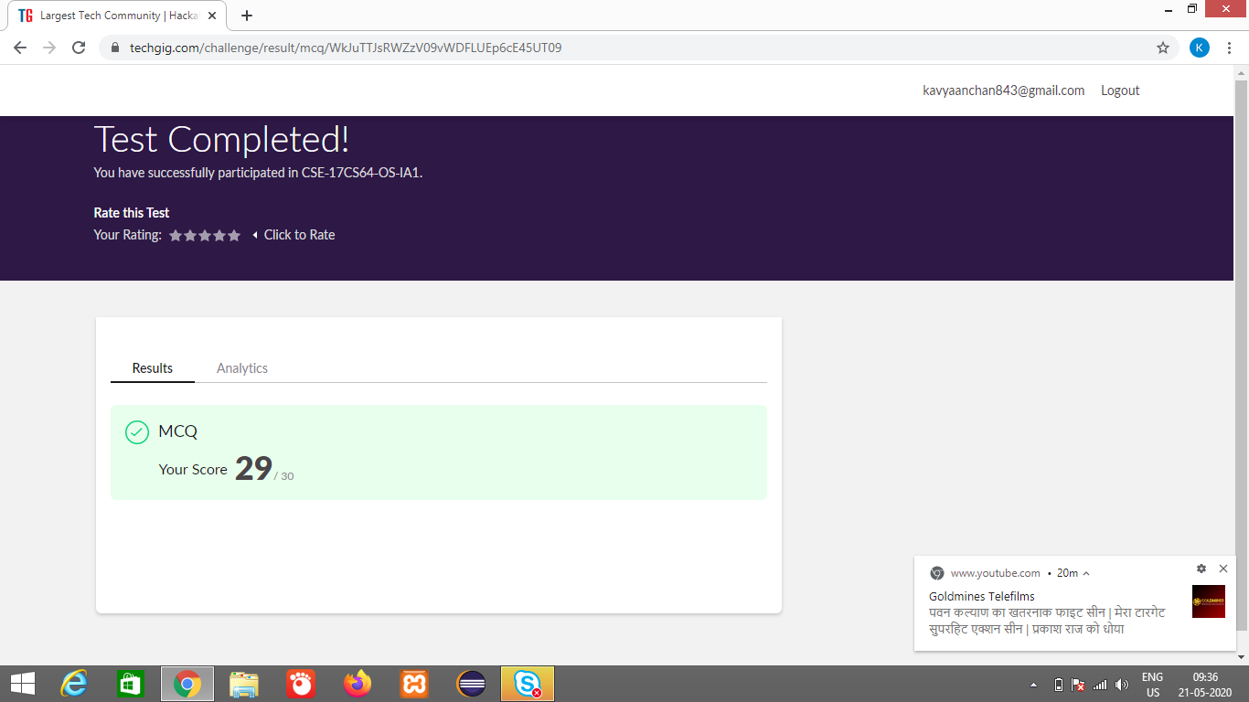

Certification Course Details: (Attach the snapshot and briefly write the report for the same)

**FLUTTER INTERMEDIATE COURSE**

We will be learning how to use some more advanced widgets and concepts for the flutter framework. And I learnt

- Expanded & Flex

- GridView widget

- How to use IOS widgets

- Notification widgets

- PageView widget

- Sliver widget

- Stack widget

- Json request widgets

- How to save data with shared preferences

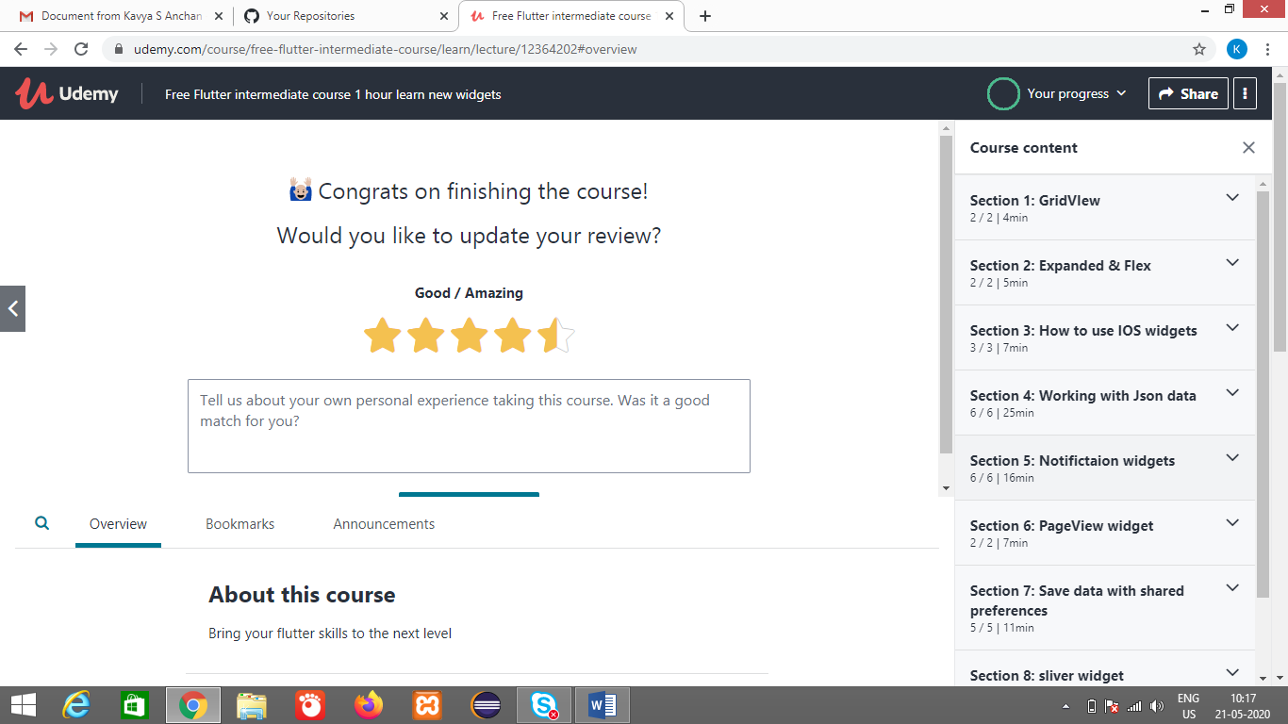

Coding Challenges Details: (Attach the snapshot and briefly write the report for the same)

Repository Name:https://github.com/kavya-077/DAILY-STATUS